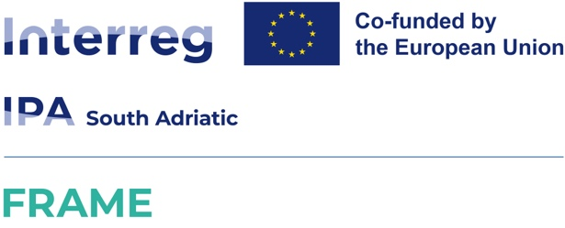

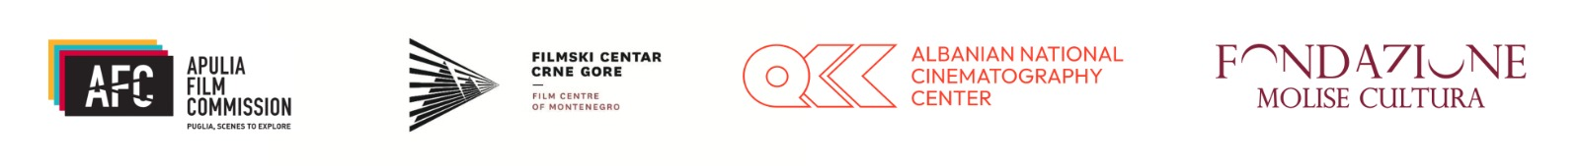

Annex 2
Declaration of compliance with eligibility requirements

(To be completed separately by each partner: both Lead Applicant and co-producer)

To the kind attention of Apulia Film Commission Foundation

Subject: FRAME project (Fostering Regional Advancement and Market Expansion of Audiovisual SMEs in the South Adriatic), funded under the INTERREG IPA South Adriatic 2021/2027 Programme. Declaration of compliance with eligibility requirements for admission to the co-development fund “SOUTH ADRIATIC CO-DEVELOPMENT FILM FUND”. CUP: B39G25000410007

The undersigned _________________________________, born in_________________ on ___________, in acting as Legal Representative of the company:
Company name: _____________________________________________________________________

Role in the project: ☐ Lead Applicant ☐ Co-producer (Partner)

Aware of the criminal penalties provided for false statements,

DECLARES

1. Size requirements (SME status). To qualify as a Micro, Small or Medium-sized Enterprise (SME) pursuant to Commission Recommendation 2003/361/EC.

2. Activity Code and Registration (Art. 2, letter a)
- To operate primarily in the audiovisual production sector (NACE / ATECO code 59.11 or equivalent)
- To be duly registered in the competent register of its respective Country (CCIAA for Italy, QSR/Qendra for Albania, CRP for Montenegro).

3. Financial soundness (Art. 2, letter b)
- NOT to be an “undertaking in difficulty” within the meaning of Regulation (EU) 651/2014.
- NOT to be subject to insolvency proceedings and not to be in dissolution or liquidation.

4. Tax and Social Security Compliance (Art. 2, letter c). To be compliant with obligations relating to the payment of taxes, duties, and social security contributions.
5. Other Requirements (Art. 2, letter d)
- To comply with occupational health and safety regulations and applicable collective labour agreements.
- Not to be subject to disqualifying conditions under anti-mafia legislation.
- Not to have been subject to total revocation of public funding in the six years preceding this application.

AUTHORIZATION FOR THE PROCESSING OF PERSONAL DATA.
The undersigned declares to have read the information notice included in the Public Call and authorizes the Apulia Film Commission Foundation to process the personal data provided in this declaration, including by electronic means, for purposes related to the management of the call, publicity obligations, and controls foreseen by the Interreg IPA South Adriatic 2021/2027 Programme and Regulation (EU) 2016/679 (GDPR).

Place and Date: _______________________

Signature of the Legal Representative of the Lead Applicant

(For ITALIAN Lead Applicants: Digital signature in PAdES format mandatory)
(For FOREIGN Lead Applicants: Handwritten signature)

_______________________

