MEDITERRANEAN
COPRODUCTION FORUM

1st edition
Lecce, 18-19-20 April 2010

The Cultural Association “Art Promotion” in collaboration with Apulia Regional Administration – Local Authority to the Mediterranean - Sector Cultural Activities and with the Foundation Apulia Film Commission will realize the “1st Mediterranean Coproduction Forum” from 18th to 20th April 2010 in Lecce during the XI European Cinema Festival with the aim of supporting the film project linked to the Mediterranean and the Balkanic regions, enhancing the meeting and the partnership among the operators of the field such as production companies, financers, experts of markets and distributors.

The programme will include seminars and meetings among producers, distributors, film commissioners, authors and directors with the aim of fostering the coproduction processes and an exchange of best practices in order to improve the operative modalities of the actors involved in the Forum.
The event will be enriched of many occasions for official and informal meetings in a convivial atmosphere.
Objective: to allow the participants to work together within a Forum in order to discuss and present their projects with the opportunity of “testing them” in their development stage and to come into contact with potential co-financers. In short, a precious verification which will help them in the next steps of production.
Place of the event: Hotel President, Lecce - Italy
Dates of the event: 18th -19th -20th April 2010
It is an event co-financed with funds “P.O. FESR Puglia 2007-2013 - Asse IV - Linea d'intervento 4.3”
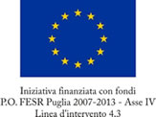

Managed by: Cultural Association ART PROMOTION
Tel: +39 0832 524565 - Fax: +39 0832 524566
mobile: +39 329 0551553
www.festivaldelcinemaeuropeo.it
forum@festivaldelcinemaeuropeo.it

PROGRAMME
1st day: Sunday April 18th 3.30p.m.
- Participants registration
- Welcome message (Organization and Apulia Film Commission)
- Presentation of the Selected Projects: on the basis of the number of the selected projects, an established amount of time will be given to each participant director in order to present his own project.
- Professional Meetings: individual meetings during which directors and producers of every project meet potential co-producers and financers. The meetings are organised for every producers and every director in the first step of the event, so that every programme reflects the interests and needs of every participant.
- Dinner
2nd day: Monday 19th April
- European Production Workshop - “Evolution of national and supranational supports to the cinematographic industry”, in collaboration with MEDIA Desk Italy 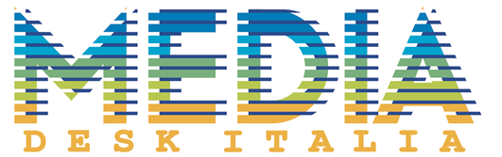
- Lunch
- Professional Meetings: individual meetings during which directors and producers of every project meet potential co-producers and financers. The meetings are organised for every producers and every director in the first step of the event, so that every programme reflects the interests and needs of every participant.
- Dinner
3rd day: Tuesday 20th April
- Location tour: to show the participants to the forum some of the most beautiful Apulia set locations, in collaboration with Apulia Film Commission
- Lunch in tour
- Closing of the activities (visit to the Cineporto in Lecce)
- Opening Event European Cinema Festival (screening +party)

