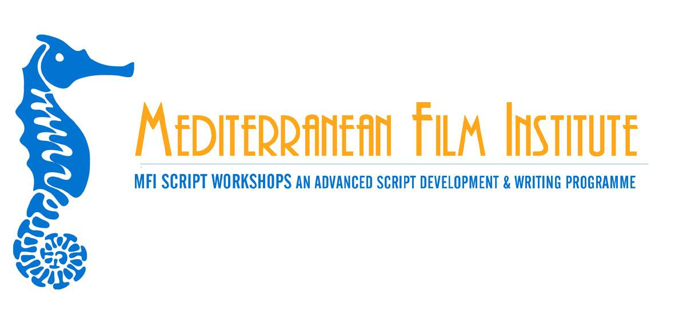

MFI SCRIPT 2 FILM WORKSHOPS

Call for Applications – 2009 Season

MFI Script 2 Film Workshops is an advanced training initiative under the umbrella of the MEDIA Programme of the European Union. Essentially a script & project development program, it is based on group work, Q&Α sessions, case studies & individual consultations, and consists of 4 intensive workshops (2 on-location in the Greek islands of Nissyros and Samos, and 2 on-line hosted in MFI’s web site).

Its primary objective is to fully develop the participating screenplays, from first or subsequent draft to final draft. Through a process of workshops that emphasize on script analysis, revision & rewriting, the activity is designed to enhance the artistic values of the story material, in the same time aiming to produce solid screenplays that will have a strong dramatic impact to international audiences.

Its second objective is to help participants to set up an effective project development process (presentation, pitching, fundraising & production strategies). The activity offers European film professionals an integrated knowledge of all aspects of project development, aiming to introduce participants to the international industry needs & practices, offer them the tools to improve their project’s production potential in terms of markets & audiences, and help them reach the stage of production.

The 2 residential and the 2 on-line workshops make up an intensive half year-long program based in the spectacular Greek islands of the Eastern Aegean. Some of the most established screenwriting teachers as well as producers & industry representatives from Europe and the USA are engaged as trainers in the activity. Furthermore, MFI invites renowned international filmmakers and industry experts for its lectures and Q&A sessions.

FIRST SESSION: June 22 – July 6 2009 ISLAND OF NISSYROS, GREECE
SECOND SESSION: September 2009 ON-LINE
THIRD SESSION: October 11-18 2009 ISLAND OF SAMOS, GREECE
FOURTH SESSION: December 2009 ON-LINE

The program is open to European screenwriters, as well as teams consisting of screenwriter & director, screenwriter & producer, or screenwriter & director & producer, with a feature film project in development. The activity is designed to accommodate 30 participants (including teams following a project).

EXTENDED APPLICATION DEADLINE: APRIL 10, 2009 - see instructions on application form

For application form & guidelines, and a complete profile of MFI and its activities please visit our website: www.mfi.gr. For more information you can contact the Mediterranean Film Institute.

MFI Script 2 Film Workshops program has a tuition fee of 1.500 € for each screenwriter with a project. In case of teams following a project: 1.000 € for an extra person & 500 € for a second extra person. Accommodation and board are covered by the program.

With the support of the Media Programme
of the European Union

With the support of

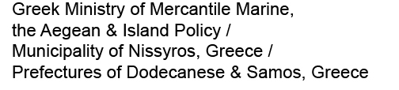

Member of the

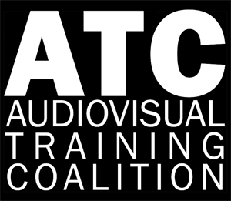 Group

_______________________________________________________________________
Mediterranean Film Institute Varvaki 38, 11474 Athens, Greece
Tel./Fax: +30 210 6457223 E-mail: info@mfi.gr web site: www.mfi.gr

