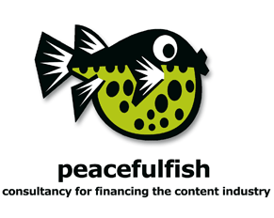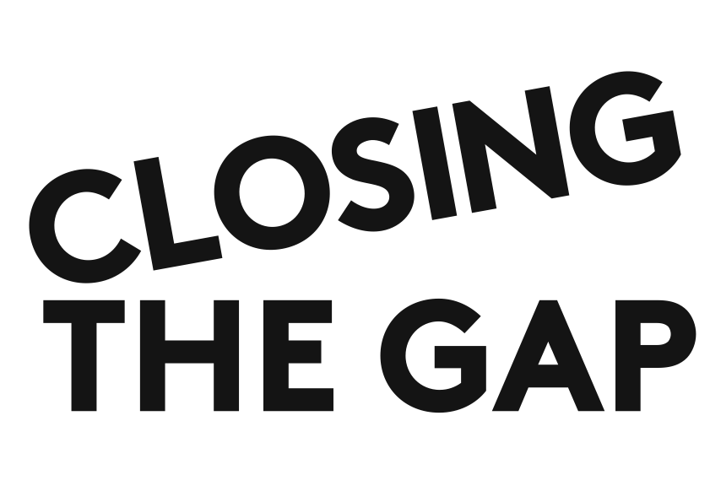

CLOSING THE GAP: EQUITY INVESTMENT FOR 360° CONTENT
TRAINING COURSE

APPLICATION FORM 2012

APPLICATION DEADLINE: 15 March 2012
SEND COMPLETED APPLICATIONS BY E-MAIL TO: closingthegap@peacefulfish.com

Applicant Name
Job Title
Nationality
Project Title
Format (ex.: theatrical film, TV series, documentary, etc.)
Budget in €
Company Name
Address
Telephone
Mobile
E-Mail
Website
2nd Participant (if applicable)
Name
Job Title
Nationality
E-mail

Together With This Signed Form, Please Submit A Single PDF Document Including:

- a half-page cover letter introducing the project: logline, current status, etc.
- CV of the producer including track record and confirming proficiency in English
- a half-page synopsis of the project’s story
- a financing plan for the project
- if a director is attached, a link to one example of his/her completed work online
- if applying for a scholarship, a 1-page letter describing why you would not be able to participate in the training course without financial assistance
- . . . attach a separate PDF of the draft screenplay

Selected producers/teams will be announced by mid-April 2012. Producers must confirm their participation within 1 week of selection. Course fees will be due 1 week after confirmation of acceptance. PLEASE NOTE: working language of this training course is English; please submit all documents in English.

SIGNATURE: _________________________________ DATE: _________

